Name: _____________________________________________________ Per. ________
2018 Q1Q2 Metric B

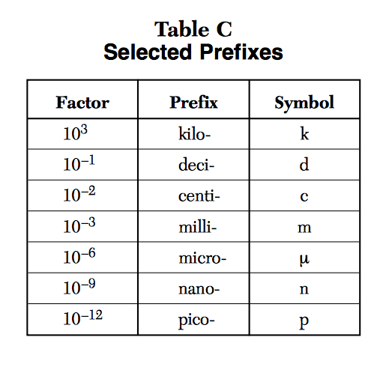
1. Describe how you would move the decimal when converting μm to mm?

2. Describe how you would move the decimal when converting J to kJ?

3. Describe how you would move the decimal when converting m to cm?

4. Describe how you would move the decimal when converting pg to g?

5. What is the factor value for any base unit missing from this table?

For questions 6 – 8: Complete the metric conversion by unit analysis.
** You can use the example below to help you show the proper setup and solve.
REMEMBER to Keep sig figs the same!

Example: 2.35 km = ____________ m the table tells us 1 km = 1000 m

2.35 km x 1000 m = 2350 m (km cancels out and notice decimal
1 km moved 3 places to the right)

6. .0550 m = ____________ cm

7. .000350 kJ = ____________ J

8. How many μL are in 2500 mL?

Questions 9 – 22: Complete the DRUL metric conversion.
** REMEMBER to Keep sig figs the same!

9. Which of the following is the longest length?
1. 2.710 x 10³ m 3. 27100000 μm
2. 27.10 km 4. 27100 cm

10. 1013000 Pa = _______________ kPa

11. 3500 J = ______________________________ kJ

12. 750 mL = ______________________ dL

13. 500. g = _____________________ kg

14. .09500 g = ___________________________ μg

15. .00025 mmol = ________________ μmol

16. 920000 ng = ________________________ pg

17. 2.09 x 10⁻⁴ m = __________________________ mm

18. 6.25 x 10⁷ μL = ___________________________ L

19. .0000325 J = _________________________μJ

20. 3.270 x 10¹² pm = _____________________ km

**HONORS OPTION**

21. If 1 mL = 1 cm³ = 1 cc then 20000 cc = _____________μL

22. If 1 Cal = 1000 cal then 1120 Cal = ______________ cal

