2018 Chem R/H Phase diagrams:

The 3 phases of mater (solid, liquid and gas) are the result of:
1. Temperature
2. Pressure
3. Attractive forces

Heating/cooling curves:

- Demonstrate the heating or cooling of a substance with the phase change transitions with respect to changing temperature over time only.

- This is a Constant pressure graph, which means in general the data for these graphs is taken at or near Standard “sea level” pressure of 1 atm (atmopheres) OR 101.3 kPa (kilopascals)
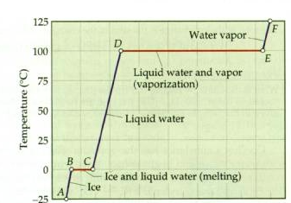

What we need to know:
AB | Solid KE increases as Temp increases PE constant
BC | Solid Liquid Equilibrium KE and Temp constant PE increases
CD | Liquid KE increases as Temp increases PE constant
DE | Liquid gas Equilibrium KE and Temp constant PE increases
EF | Gas KE increases as Temp increases PE constant

What happens if pressure and temperature change when you heat a substance?

- You get a very useful graphical representation called a phase diagram.

- Unlike heating/cooling curves, phase diagrams demonstrate changing temperature and pressure conditions.
- Phase diagrams are a very convenient way of representing the phases of a substance as a function of pressure versus temperature.

- Below is a sample phase diagram for most substances:

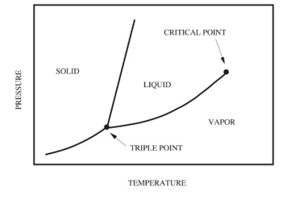
Things you must identify on any phase diagram:
- Solid, liquid and gas phases
- Melting/freezing, evaporation/condensation and sublimation/deposition points.
- The Normal boiling/condensation and melting/freezing points (P = 1 atm)

- Triple point conditions of temperature and pressure where all three phases exist in equilibrium (in a closed system)
- Critical point Basically, the gas and liquid phases are indistinguishable because they have the same density (often referred to as the supercritical fluid region).
- Critical temperature the temperature above which the vapor can NOT be liquefied no matter what pressure is applied.

- Critical pressure the pressure required to produce liquefaction (solid and/or gas liquid) at the critical temperature
- Observe the slope of the solid-liquid line. In the above diagram it is a positive slope, and this is typical for most substances. However, water has a unique negative solid-liquid slope line compared to the positive solid-liquid slope line seen for most substances.

Water ( - slope solid/liduid line)
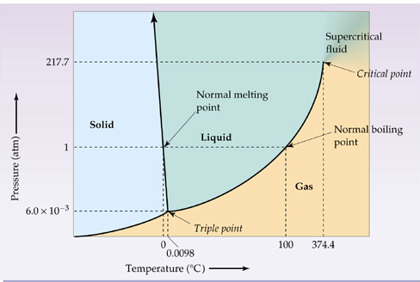

Carbon Dioxide (+ slope solid/liquid line)

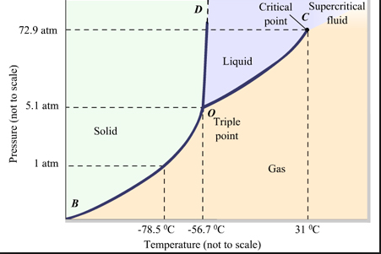

Some important distinctions using the Water vs. CO₂ Phase diagrams:

Water has a negative slope solid-liquid line…what does this mean?
- You already know something unique about water in it's solid phase that the solid is less dense than the liquid (ice floats in liquid water).

- For most substances, like carbon dioxide, the solid phase is denser than the liquid phase. The particles are packed closer together in the solid, so increasing the pressure really can’t push the particles any closer than they already are.

- Look at the spacing in the particles of a substance like carbon dioxide:

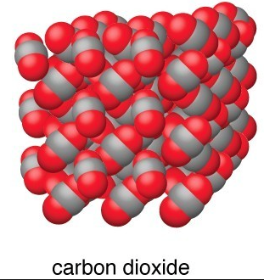

- YOUTUBE… if you place a weighted wire on a block of dry ice over time and you will see it will not change the solid dry ice at all (string will not cut through). Thus increasing the pressure does not change it to a liquid.

- Water is a special case: Water, on the other hand, becomes LESS dense when it freezes.

- This happens because when water freezes large empty spaces form between the molecules

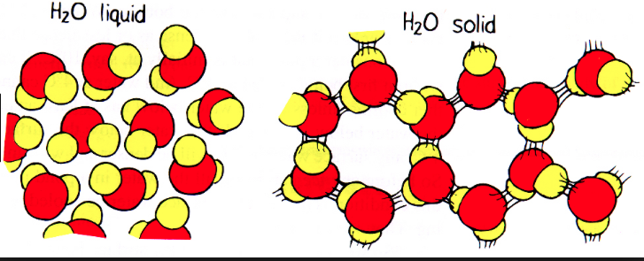
- YOUTUBE… if you place a weighted wire on A block of ice, H₂O(s), the weighted wire will get cut through the ice because the wire increases the pressure on the ice, essentially liquefying it as it cuts through.

- Pick points on the phase diagram for water to prove this?

